**MEDICAL REALITY**

FINAL REPORT

***PROJECT AND TEAM*** 3

***PROBLEM/SOLUTION OVERVIEW*** 4

***NEEDFINDING*** 5

➢ *Domain of interest* 5

➢ *First round of interviews* 5

• *Methodology and procedure* 5

• *Results* 7

➢ *Initial synthesis* 8

• *Full list of the brainstormed (initial) needs* 8

• *The most insightful (initial) user needs* 9

• *The most focused domain of interest* 9

➢ *Second round of interviews* 9

• *Methodology and procedure* 9

• *Results* 10

➢ *Synthesis* 11

• *Brainstormed user needs* 11

• *The 3 deep user needs selected* 11

➢ *Solutions* 12

• *The 5 solutions for each deep user need* 12

• *The top solution picked* 12

***TASKS AND STORYBOARD*** 13

➢ *Simple, moderate, and complex tasks* 13

➢ *The storyboard* 14

***LOW-FIDELITY PROTOTYPE*** 15

➢ *Modalities explored* 15

➢ *Paper prototypes* 15

• *The two realized paper prototypes* 15

• *How they connect to the storyboard* 17

• *The high-level flow* 18

➢ *Selection rationale* 20

• *Pros and cons for each prototype* 20

• *Chosen prototype* 21

***MEDIUM-FIDELITY PROTOTYPE*** 22

➢ *The images of the rough sketches created* 22

➢ *How the medium-fidelity prototype was created* 23

➢ *The most significant screens* 24

➢ *Link to the interactive medium-fidelity prototype* 27

***HEURISTIC EVALUATION*** 28

➢ *The heuristic evaluation received* 28

➢ *Severity level 3 or 4 heuristic violations* 28

➢ *Plan to solve the identified violations* 33

***HIGH-FIDELITY PROTOTYPE*** 42

➢ *How the high-fidelity prototype was created* 42

➢ *Link to the high-fidelity prototype GitHub repository* 42

➢ *Overall architecture of the application* 42

➢ *Hard-coded part, pre-stored data, and limitations* 46

***USABILITY TESTING*** 48

➢ *Preparation and run* 48

• *Evaluation conducted* 48

• *Link to the usability testing protocol PDF* 48

➢ *Results* 49

• *The results and findings summary* 49

• *Information learned about the prototype* 50

• *Potential changes to fix the main issues emerged* 51

***CONCLUSIONS*** 52

➢ *Main learnings in the course* 52

➢ *Group feedback* 52

# ***PROJECT AND TEAM***

* ***Project Name:*** Medical Reality.
* ***Value Proposition:*** Train on Bytes before training on real bodies.
* ***Team Members:*** 
  + Grande Francesco (s296962)
  + Marra Benito (s295220)
  + Rota Luca (s303941)
  + Sciara Lorenzo (s303462)
* ***Group Name:*** Front-end-Avengers.

# ***PROBLEM/SOLUTION OVERVIEW***

* ***Problem:*** Students need to have more knowledge before the start of the pre-training. Most of the students interviewed expressed their feeling of inexperience at the beginning of the internship.
* ***Solution:*** Provide interactive materials to learn-alone. The student can be part of an immersive experience: he can participate in a training simulation, interacting with the surrounding environment and receiving feedback, in order to increasing realism.

# ***NEEDFINDING***

## *Domain of interest*

* ***Domain:*** VR/AR for medical education.
* ***Why:*** We chose the preparation of medical training, because we thought it could improve the daily activities that a medicine student does.

## *First round of interviews*

### *Methodology and procedure*

* ***Interviewed:*** We interviewed three medical students as immediate users and the hospital medical director, who oversees the trainings in «SimTO», as extreme user.
* ***Interview location:*** We carried out interviews of students at the medical university, in a bar and at Polito, while the interview to the extreme user, at his office and the «SimTo».
* ***Interview method:*** The interviews were made by all the group members, divided into groups of 2 people, with the only exception of the extreme user that was interviewed by the whole group together.
* ***Interview tools:*** We used a prepared file containing questions, which we followed as a guideline, making variations based on respondents' answers and we used phones to record their voices, so we can re-listen the interview and better understand their needs.
* ***List of questions:*** 
  + Background Questions:
    - What’s your name?
    - What’s your occupation?
    - How old are you?
    - Can I call you …?
    - Do I have your authorization to share and to elaborate your answers in this interview?
    - When and how did your passion for medicine start?
    - How long have you been in the field of medicine / do you study in this area?
    - How is your relationship with technology?
    - How much do you use technology in your daily life?
  + Going Deep Questions
    - How do you estimate the average practical ability of students when they start the training? (extreme)
    - How did you estimate his practical ability at the time he started his training?
    - How would you compare it to the current level of medical students? (extreme)
    - How do you consider your practical ability once you have finished your training? (extreme)
    - What does the current training consist of?
    - Can you explain in detail how the pre-training and training for medical students are constituted?
    - How much time does it take in practical training compared to theory?
    - How much time do students spend in the practical training compared to the theoretical part? (extreme)
    - How were the trainings supported during the Covid period?
    - How would you evaluate the possibility for your students to practice more at home? (extreme)
    - How much did you spend to buy the tools to be able to exercise? Such as the stethoscope, etc.…
    - Do you believe that the equipment provided to students is sufficient for their pre-training?
  + Clarification/Successes and Failures Questions
    - On a scale from 1 to 10, how do you rate the medical education system in Italy?
    - On a scale from 1 to 10, how did you estimate your practical ability when starting your training?
    - In your opinion, what is an advantage and a disadvantage of your training?
    - In your opinion, what is an advantage and a disadvantage of the trainings you have followed? (extreme)
    - In your opinion, what are the three most deficient points of the current training system in relation to the organizational system? (extreme)
    - So, given the opportunity, what would improve the current training system?
  + Reflection Questions
    - What do you think about Virtual/Augmented Reality in this field?
    - Do you think that it could be helpful towards the actual system?
    - Do you think that the Medical Educational System could change in the short future?

### *Results*

* ***Pictures***:

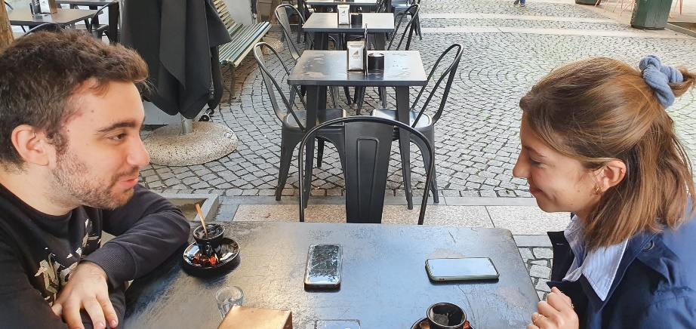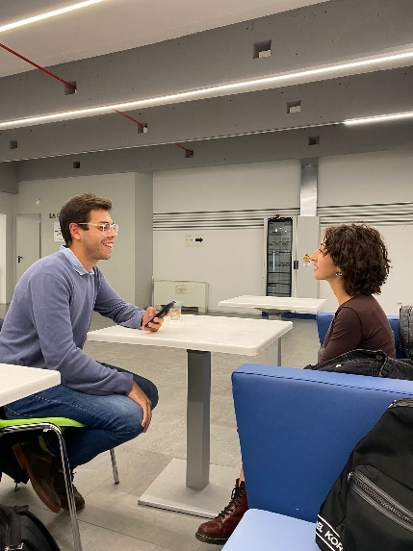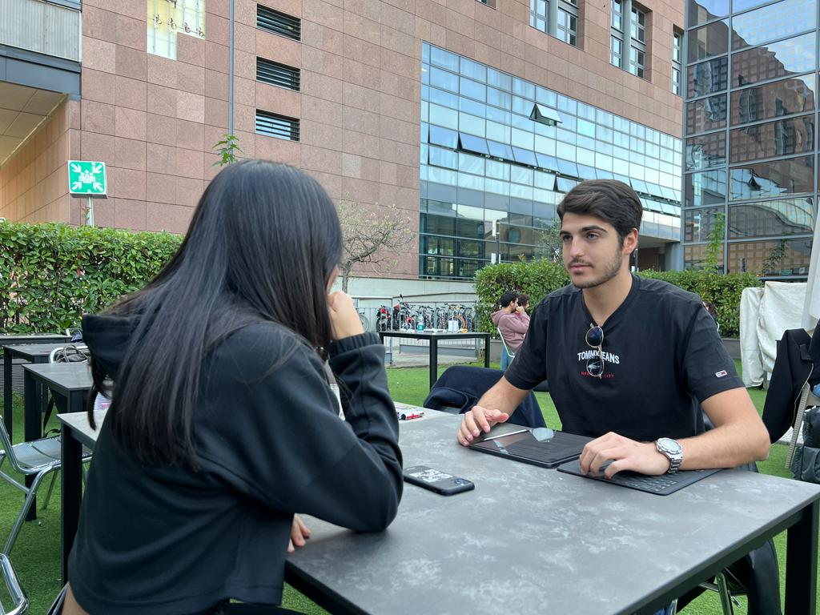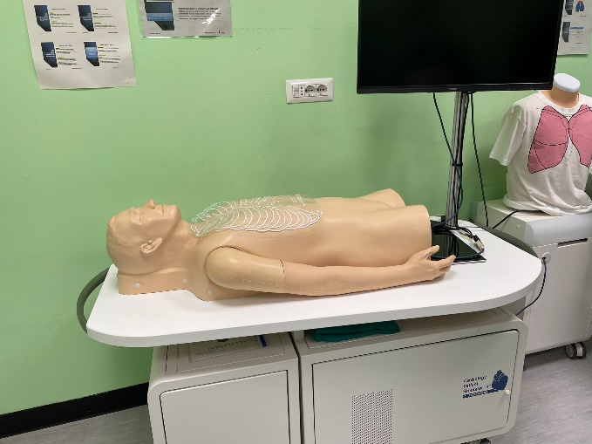

* ***Summary of the immediate users’ interviews:***

We have chosen students who have different experience with the trainings: one, for example, had never participated to one of them, whereas another student had already ended all the trainings. The reason behind this choice is that we wanted to underline their expectations and their final thoughts on the actual trainings in order to highlight which problems there are in the current system and how to fix them.

* ***What we learned from immediate users:***
  + All the students think that the training is not enough for the courses
  + The students don't believe in possible changes in the near future
  + The idea of being able to get some practice at home is exciting for everyone
  + Buying all the real tools might be expensive for some students
  + Students are disappointed by the actual medical education in Italy
  + Trainings are made by reservation, so it is not available instantly
* ***Summary of extreme user’ interview:***

We interviewed Grazia Papotti, one of the hospital medical director who is in charge of the trainings in «SimTO», a structure used by med students to train with fake bodies. She’s experienced different methodologies to teach and probably knows well what the students are in need of and how to give them the best teaching experience possible. With 20 years of experience in this field, she is also an expert user.

* ***What we learned from extreme user:***
  + There are already a lot of software and simulators for first degree pre-training, but none of them are made with virtual reality
  + There are too few mannequins available compared to many students, due to the high price
  + There is a need to have more rooms to have more groups of students simultaneously
  + There is a need to save time because a student can only do 3 internships per year
  + There is a need to make the training experience more realistic
  + The virtual reality could be more useful in post-degree courses than pre-training courses, especially in the surgery field

## *Initial synthesis*

### *Full list of the brainstormed (initial) needs*

* ***Full list of needs:*** 
  + Students need more training in the courses
  + Students need to believe more in the future of teaching
  + Students need to get some practice at home
  + Students need less expensive tools
  + Students need a better medical education in Italy
  + Students need an instantly availability of trainings
  + Training manager needs more mannequins for all students
  + Training manager needs more rooms to have more groups of students simultaneously
  + Training manager needs to save time, since a student can only do 3 internships per year
  + Training manager needs to make the training experience more realistic
* ***Links to interviews:*** 
  + [Interview of Gaia La Torre (immediate user)](https://github.com/polito-hci-2022/Front-end-Avengers/blob/5be95b71015bfe029b3508415b41645c31772c18/A1/Audio%20Recordings/Gaia.mp4)
  + [Interview of Cristina Gili (immediate user)](https://github.com/polito-hci-2022/Front-end-Avengers/blob/5be95b71015bfe029b3508415b41645c31772c18/A1/Audio%20Recordings/Cristina%20Gili.mp4)
  + [Interview of Camilla Monchio (immediate user)](https://github.com/polito-hci-2022/Front-end-Avengers/blob/5be95b71015bfe029b3508415b41645c31772c18/A1/Audio%20Recordings/Camilla.mp4)
  + [Interview of Grazia Papotti (extreme user)](https://github.com/polito-hci-2022/Front-end-Avengers/blob/5be95b71015bfe029b3508415b41645c31772c18/A1/Audio%20Recordings/Grazia%20Papotti.mp4)

### *The most insightful (initial) user needs*

* ***List of most insightful needs:***
  + Students need to spend more time in trainings
  + Students need to train with adequate training tools
  + Students need to experience a more realistic training
  + Students need a better basic preparation
  + Training Manager need to have more time on the important aspect of the facility
* ***Why:*** We began to focus on these needs as they were the most common among respondents, as well as the most appropriate ones to treat for the following project given our skills.

### *The most focused domain of interest*

We focus on the preparation of medical training, because we thought it could improve the daily activities that a medicine student does and their preparation in this filed; moreover, because for the training manager it is not easy to manage all students in this path with its few means available.

## *Second round of interviews*

### *Methodology and procedure*

We interviewed two medical students, in two different meetings, through the Discord platform, so we can reach people in different regions of Italy. All the interviews were made by almost two of us, one asking the questions and others one taking notes of the interviewee’s answers, and were audio recorded. We have chosen students who have different experience with the trainings and before each interview a document was signed by the interviewees: it allowed us to use the pictures you will see in this presentation.

### *Results*

* ***Pictures***:

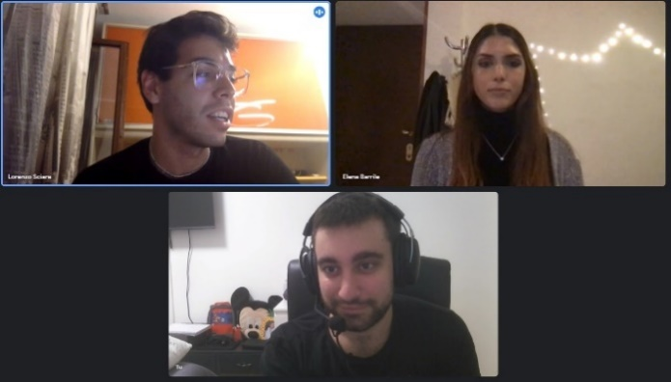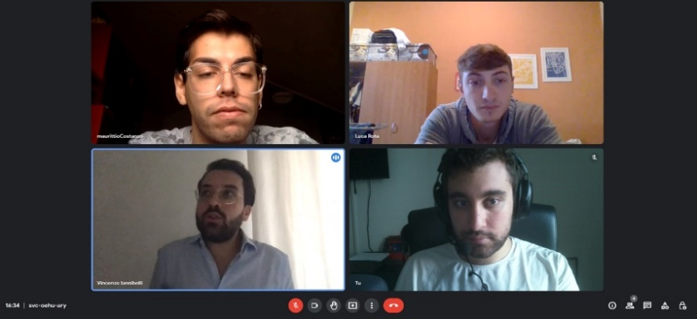

* ***Summary of the immediate users’ interviews:***

Both new respondents had a lot of experience in the medical field and were able to experience different types of training; since they studied in two distant parts of Italy, it emerged from the interviews that the approach to training was also different. Both think that the theoretical part of their studies is greater than the practical part, with different points of view: Elena believes that it would be useful to have more hours of internship, while Vincenzo thinks that theoretical studies are very important also about the preparation for the training.

* ***What we learned from immediate users:***
  + One student thinks that the training is not enough for the courses
  + One student thinks that the theoretical part, relative to the training is not enough for the courses
  + There is a different cost to bear for medical tools based on university
  + There are different approaches to internships based on the region in which the student is located
  + The idea of being able to get some practice at home is exciting for everyone
  + Students are disappointed by the actual medical education in Italy

## *Synthesis*

### *Brainstormed user needs*

* ***Pictures***:

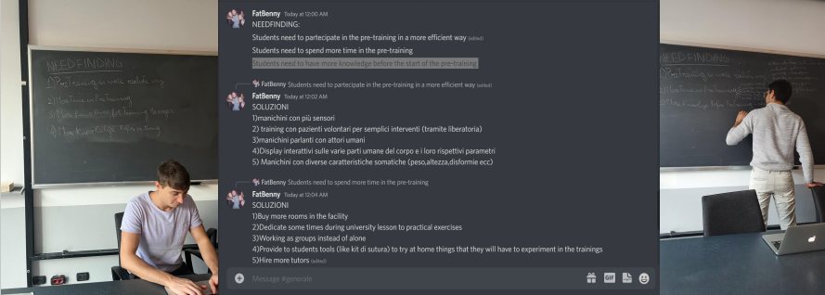

* ***List of brainstormed user needs:***
  + Students need to train with adequate training tools
    - [Interview3](https://github.com/polito-hci-2022/Front-end-Avengers/blob/5be95b71015bfe029b3508415b41645c31772c18/A1/Audio%20Recordings/Cristina%20Gili.mp4), [Interview5](https://github.com/polito-hci-2022/Front-end-Avengers/blob/5be95b71015bfe029b3508415b41645c31772c18/A2/Audio%20Recordigs/ElenaBarrileInterview.zip)
  + Students need to experience a more realistic training
    - [Interview1](https://github.com/polito-hci-2022/Front-end-Avengers/blob/5be95b71015bfe029b3508415b41645c31772c18/A1/Audio%20Recordings/Gaia.mp4), [Interview6](https://github.com/polito-hci-2022/Front-end-Avengers/blob/5be95b71015bfe029b3508415b41645c31772c18/A2/Audio%20Recordigs/VincenzoIannibelliInterview.zip)
  + Students need to participate in the pre-training in a more efficient way
    - [Interview1](https://github.com/polito-hci-2022/Front-end-Avengers/blob/5be95b71015bfe029b3508415b41645c31772c18/A1/Audio%20Recordings/Gaia.mp4), [Interview2](https://github.com/polito-hci-2022/Front-end-Avengers/blob/5be95b71015bfe029b3508415b41645c31772c18/A1/Audio%20Recordings/Camilla.mp4), [Interview3](https://github.com/polito-hci-2022/Front-end-Avengers/blob/5be95b71015bfe029b3508415b41645c31772c18/A1/Audio%20Recordings/Cristina%20Gili.mp4)
  + Students need a better basic preparation
    - [Interview2](https://github.com/polito-hci-2022/Front-end-Avengers/blob/5be95b71015bfe029b3508415b41645c31772c18/A1/Audio%20Recordings/Camilla.mp4), [Interview6](https://github.com/polito-hci-2022/Front-end-Avengers/blob/5be95b71015bfe029b3508415b41645c31772c18/A2/Audio%20Recordigs/VincenzoIannibelliInterview.zip)
  + Students need to spend more time in the pre-training
    - [Interview2](https://github.com/polito-hci-2022/Front-end-Avengers/blob/5be95b71015bfe029b3508415b41645c31772c18/A1/Audio%20Recordings/Camilla.mp4), [Interview3](https://github.com/polito-hci-2022/Front-end-Avengers/blob/5be95b71015bfe029b3508415b41645c31772c18/A1/Audio%20Recordings/Cristina%20Gili.mp4), [Interview5](https://github.com/polito-hci-2022/Front-end-Avengers/blob/5be95b71015bfe029b3508415b41645c31772c18/A2/Audio%20Recordigs/ElenaBarrileInterview.zip)
  + Students need to have more knowledge before the start of the pre-training
    - [Interview3](https://github.com/polito-hci-2022/Front-end-Avengers/blob/5be95b71015bfe029b3508415b41645c31772c18/A1/Audio%20Recordings/Cristina%20Gili.mp4), [Interview1](https://github.com/polito-hci-2022/Front-end-Avengers/blob/5be95b71015bfe029b3508415b41645c31772c18/A1/Audio%20Recordings/Gaia.mp4), [Interview2](https://github.com/polito-hci-2022/Front-end-Avengers/blob/5be95b71015bfe029b3508415b41645c31772c18/A1/Audio%20Recordings/Camilla.mp4)
  + Training Manager need to have more time on the important aspect of the facility
    - [Interview4](https://github.com/polito-hci-2022/Front-end-Avengers/blob/5be95b71015bfe029b3508415b41645c31772c18/A1/Audio%20Recordings/Grazia%20Papotti.mp4)

### *The 3 deep user needs selected*

* ***List of deep user needs:***
  + Students need to participate in the pre-training in a more efficient way
  + Students need to spend more time in the pre-training
  + Students need to have more knowledge before the start of the pre-training

* ***Why:*** We chose these three deep needs because they can cover as much as possible all the needs most frequently highlighted by respondents and because they could be satisfied with the idea of prototype that we were starting to think.

## *Solutions*

### *The 5 solutions for each deep user need*

* ***List of solutions:***
  + Students need to participate in the pre-training in a more efficient way
    - Mannequins with more sensors
    - Training with volunteer patients for simple interventions
    - Talking mannequins with human actors
    - Interactive displays on the various body parts and the human parameters
    - Mannequins with different somatic characteristics
  + Students need to spend more time in the pre-training
    - Buy more rooms in the facility
    - Dedicate sometimes during university lesson to practical exercises
    - Working as groups instead of alone
    - Provide students tools to try at home things that they will have to experiment in the trainings
    - Hire more tutors
  + Students need to have more knowledge before the start of the pre-training
    - Have a chance to see in the clinic the basics of medicine
    - Provide interactive materials to learn-alone e.g., like book-games
    - Give students videos where they can see the same operation they are going to perform in the pre-training
    - Fake operations in classroom lessons where the doctor tries to replicate the thing on dead animals
    - Making groups where the student who already learnt the basic can explain
* ***Solution Creation:*** We met at the university and for about 10 minutes, for each deep need, each of us wrote on a different sheet the solutions that came to mind. Then we joined them keeping the 5 most appropriate solutions found for every need, writing them on the board.

### *The top solution picked*

* ***Top solution:*** Provide interactive materials to learn-alone.
* ***Choice of solution:*** We had a meeting through the discord platform where each of us voted 3 anonymously and the solution that got more votes was chosen.

# ***TASKS AND STORYBOARD***

## *Simple, moderate, and complex tasks*

* ***Simple task:*** Begin a new preparatory lesson to the pre-training.
* ***Moderate Task:*** Share train result to the professor.
* ***Complex Task:*** Receive tips on future medical pre-training lessons based on demonstrated skills.
* ***Why:*** We have chosen these three tasks as they should be the main things that a medical student must be able to have to prepare for the pre-training: to be able to perform virtual lessons and receive feedback from the app and the professor.

## *The storyboard*

* ***Storyboard:***

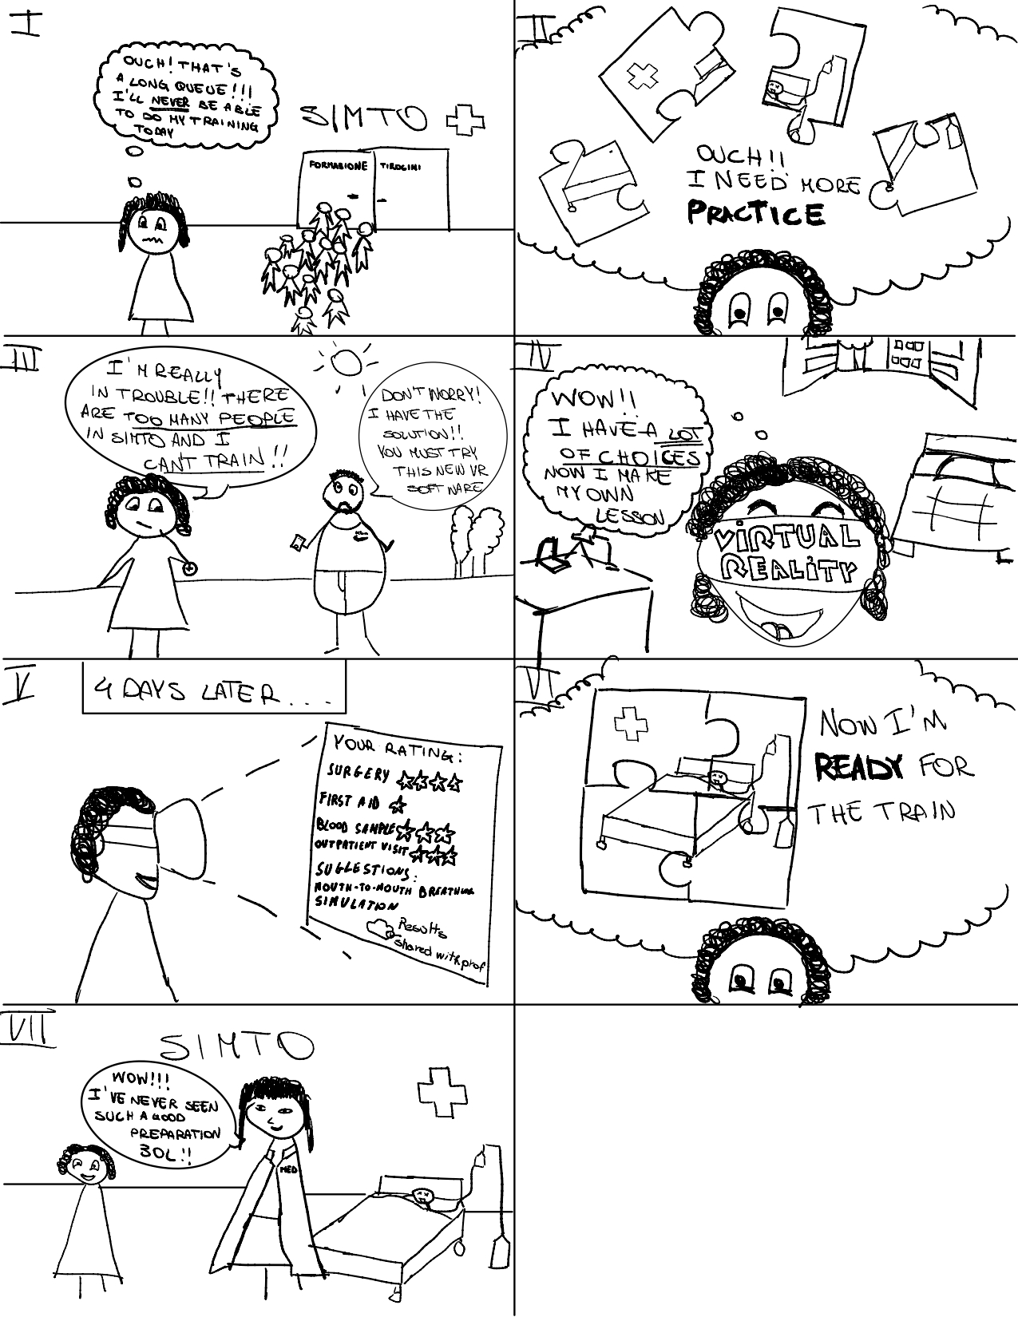



* ***Why:*** These figures best express our idea, in the simplest way.
* ***Strengths:*** It represents all chosen tasks.
* ***Weakness:*** Our drawing may not be totally clear.
* ***How well tasks are identified:*** The deep user need is represented by a puzzle, which represents a set of unclear ideas in the student, which are ordered using our application. The tasks are instead shown through the use of the viewer by the student, who receives the desired feedback after the lesson.

# ***LOW-FIDELITY PROTOTYPE***

## *Modalities explored*

* ***Alternatives considered:*** We focused on portable and immersive devices that can meet our tasks
* ***Alternatives selected:*** 
  + *Target device/platform:* Tablet / VR
    - Has an affordable cost and has a very large screen that increases the immersivity of the experience
  + *Target device/platform:* Visor / VR
    - Maximizes the immersivity of the experience and allows you to interact with the environment

## *Paper prototypes*

### *The two realized paper prototypes*

* ***Prototype 1 – Tablet / VR:***

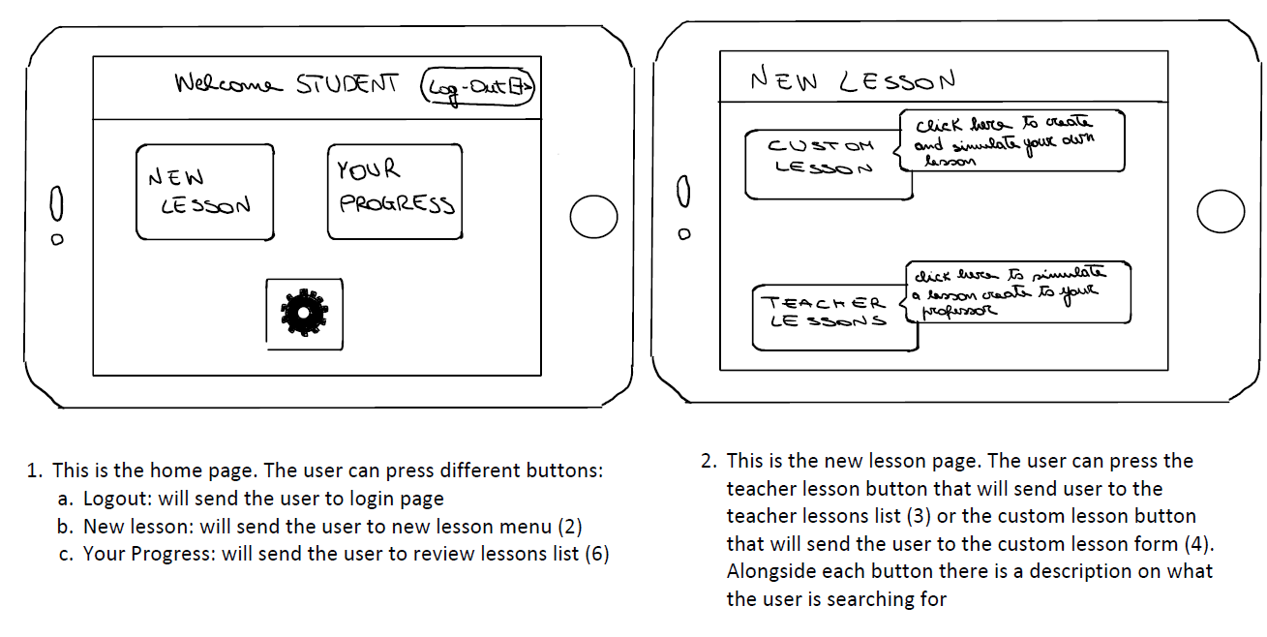

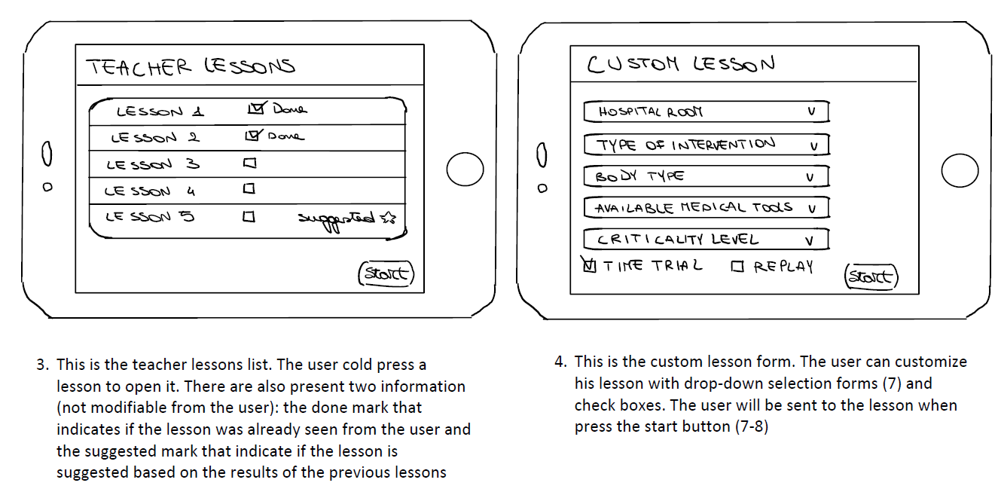

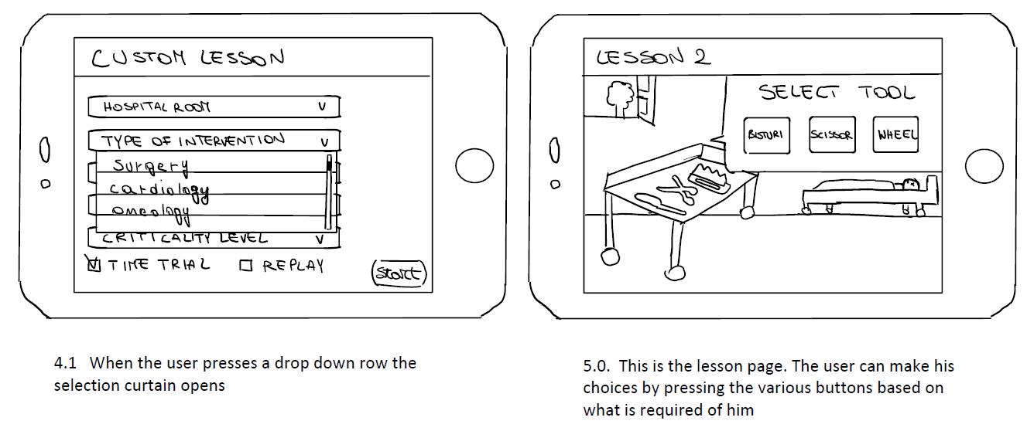

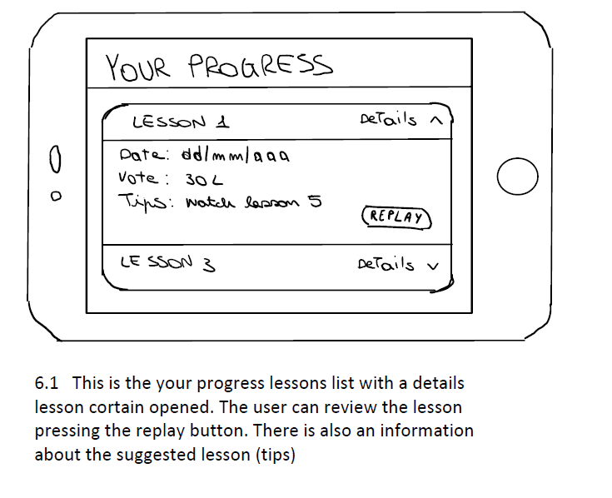

* ***Prototype 2 – Visor / VR:***

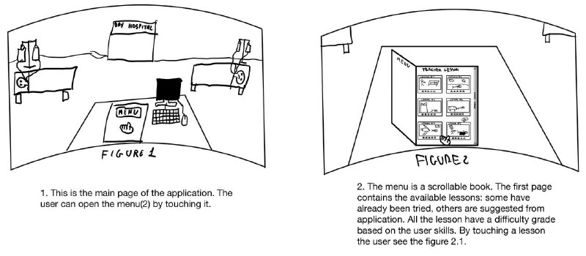

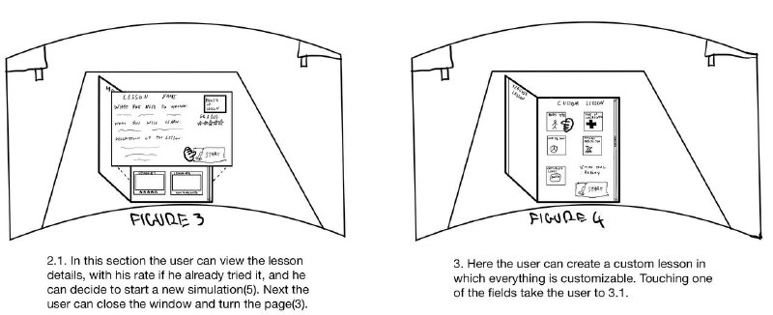

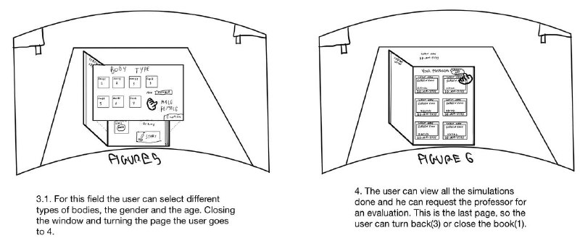

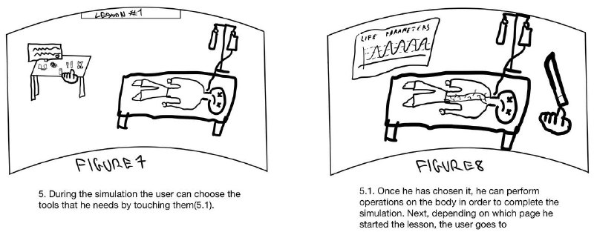

### *How they connect to the storyboard*

* ***Summary of Prototype 1:***

This prototype allows you to cover the deep need of the user chosen by us, as it allows him to have increase his knowledge in this field before starting pre-training. To do this within the prototype are developed the three tasks that we have chosen to develop:

* + “Teacher lessons” section allows the student to learn from the material provided by the professor, also exploiting the algorithm of the application that suggests which lessons to follow before or review to improve
  + “Your progress” section allows the student to monitor his progress and to validate the results obtained to the professor, in which he will respond through a channel outside the application, such as the university email (the button to do this is not visible because at the bottom of the page containing the list of lessons evaluated)
* ***Summary of Prototype 2:***

Like the previous prototype, it allows to fully cover the deep user need chosen by us, but in this case creating a much more immersive and realistic environment, suitable for the development of skills in the medical field. The structure of the prototype remains the same, but changes the graphic design, in a more user friendly and also the way the lesson is performed, given the possibility of using controllers in order to perform actions at the iteration of the same.

### *The high-level flow*

* ***Prototype 1 – High Level Flow:***









* ***Prototype 2 – High Level Flow:***









## *Selection rationale*

### *Pros and cons for each prototype*

* ***Prototype 1 – Pros:***
  + The device is portable and with moderate price
  + Different options are clearly distinguishable and easily selectable with the touchscreen
  + Pages are clearly distinguished so that the user can always know where it is
  + User can do a login
* ***Prototype 1 – Cons:***
  + The interface is not totally immersive
  + User can only interact with touch screen
* ***Prototype 2 – Pros:***
  + More immersive since people can interact with the experience using their hands directly
  + Video recordings of the simulation can help to analyze the students mistake in a very efficient way
  + It provides a more detailed view during the simulation
* ***Prototype 2 – Cons:***
  + Tiring to the eyes (virtual reality can't be used for long time)
  + Create a custom lesson requires more time since you have to scroll the book pages
  + It may be portable but it’s not optimal to use everywhere

### *Chosen prototype*

* ***Prototype:*** We chose the Prototype 2
* ***Why:*** We chose the Prototype 2 because, although Prototype 1 apparently has more pros than cons, since the main objective of the project is to provide the most interactive and immersive lessons possible, so the Prototype 2 responds better to this need. Furthermore, the menu presented by a scrollable book, in the Prototype 2, is more user friendly as it seems like a study book for the med students.
* ***Target Device:*** We chose Visor / VR

# ***MEDIUM-FIDELITY PROTOTYPE***

## *The images of the rough sketches created*









* ***Changes between the low prototype and the medium prototype:***

The main change lies in a revisiting of the menu, which goes from being single page to having two pages available to contain the lessons and other tools of the prototype. Other minor changes are: a different graphic composition of the main menu, a decrease in the possible selectable elements, within a single category in the section "Custom lesson" and a shift of the button to share with the professor the evaluations from the top of the page to the bottom in the section "Your progress".

## *How the medium-fidelity prototype was created*

* ***Tool used:*** We used Figma.
* ***Medium-fidelity Prototype creation:*** 
  + *Team member roles:* Someone was responsible for creating the frames, such as those contained in the lessons, someone to find online icons to use, someone who created the most complex objects using the basic components of Figma, such as the bed and someone who was responsible for creating the links between the various buttons and the various frames, in order to create the flow of the prototype
  + *Design process:* We worked simultaneously, dividing various tasks, we didn’t create all the frames and then make the links later, but every time a new frame was created it was filled with basic deletions, complex objects, icons and links, from the various team members
  + *How tasks are covered:* 
    - The simple task is bought by the presence of the lessons provided by the professor
    - The moderate task is covered by the button to share with the professor the obtained evaluation
    - The complex task through the presence of suggested lessons, which indicate that the intelligence of the application itself, based on the mistakes made in the other lessons, has detected certain gaps in the student
  + *Overed limits:* This prototype gave us the possibility to create a flow within the same, for example starting, pausing and stopping a lesson. Moreover, we could represent all the tools of the section "Custom lesson", with all the elements in their contents.

## *The most significant screens*

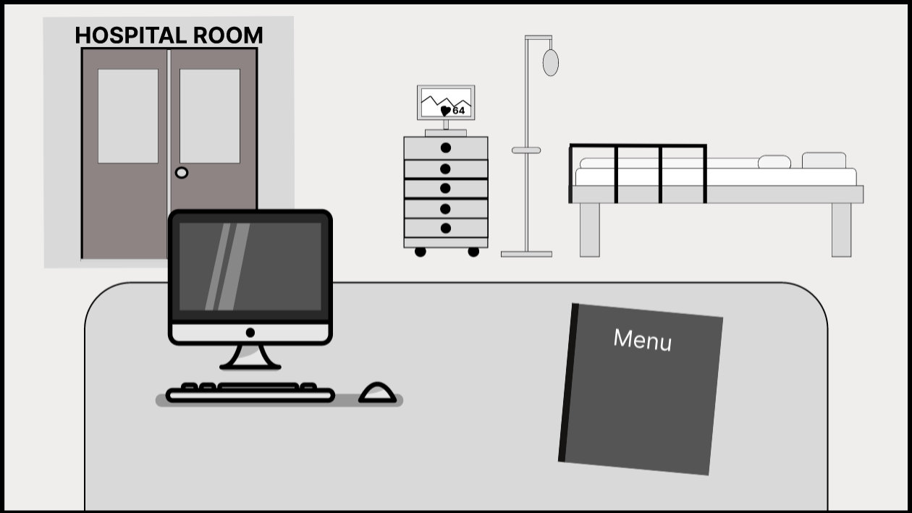

***The Home:*** Being a prototype designed to be used through a Visor, the home simulates being in a hospital room, sitting on a desk with a book in front, or the menu, which allows the student to start studying.

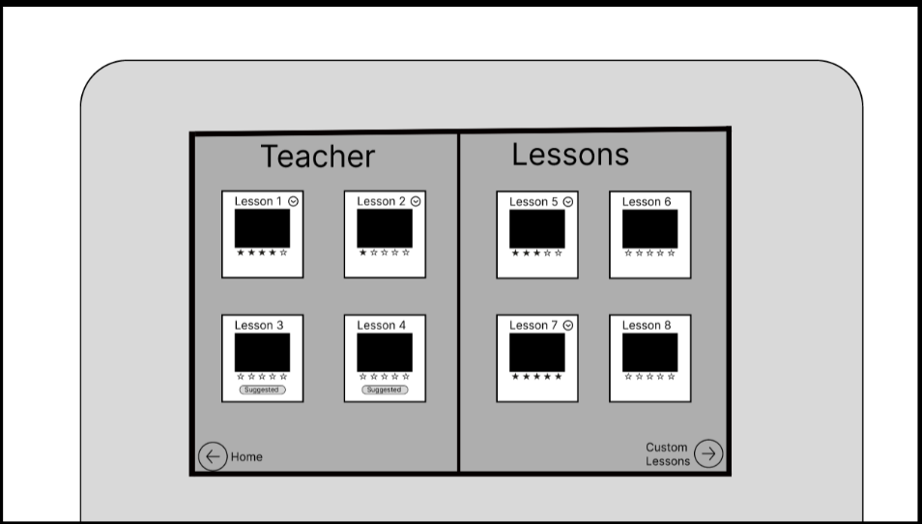

***Teacher Lessons section:*** Here you can see all the lessons provided by the professor and for each lesson there is the title, an image and a rating, equal to 0 stars for the lessons not yet made. Moreover, the lessons already made are marked by a check and those suggested are marked with a special label.

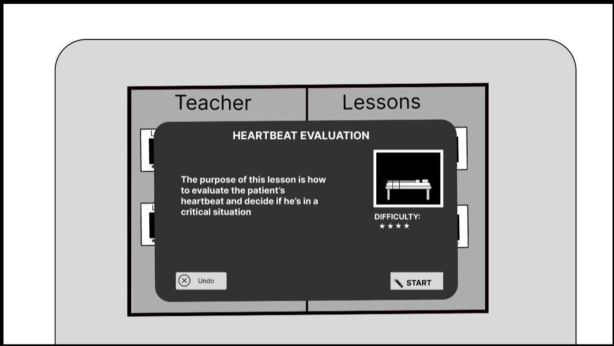

***Teacher Lessons pop-up:*** For each lesson there is a different pop-up, in which the title is indicated, a brief description and a level of difficulty, of the same. There is also the button to start the lesson.

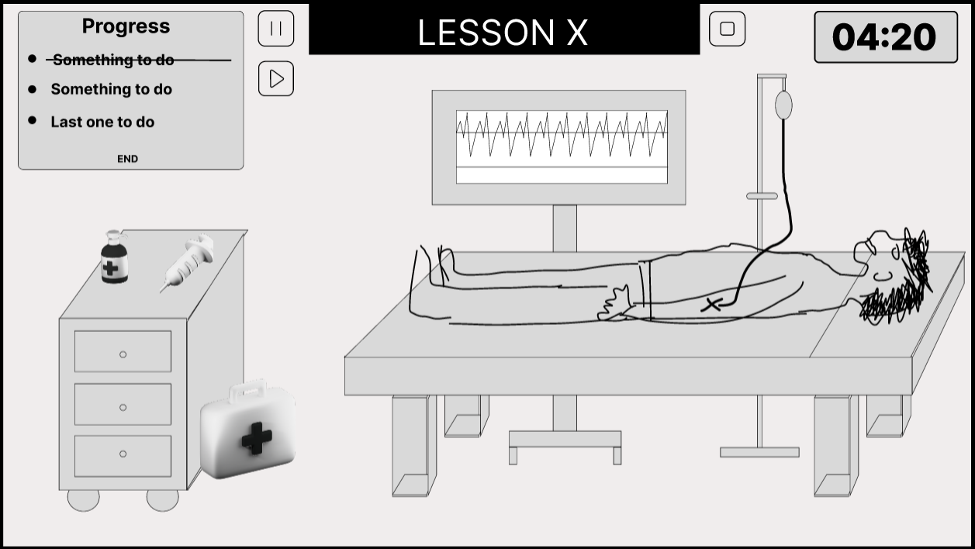

***Lesson X screen:*** In this screen there is the lesson started which, in addition to elements that make up the hospital scenario: a panel containing the tasks that must be performed, in the upper left, the pause button, stop and the lesson title, in the center and a timer, on the right.

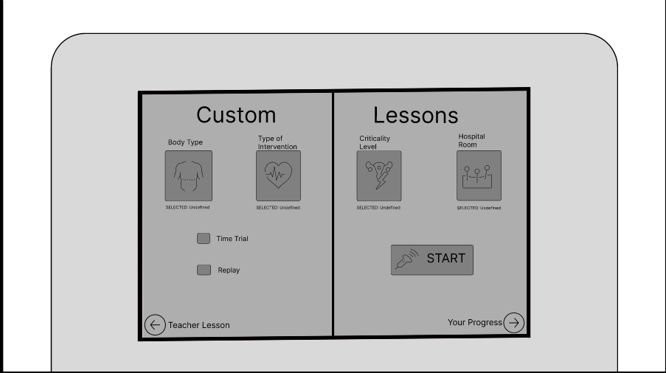

***Custom Lessons section:*** Here the student can create a personalized lesson by selecting: the type of body, the type of intervention, the level of criticality and the intervention room. Moreover, he can set two additional features for the lesson, such as: "time trial", which adds a timer set according to the difficulty level of the lesson that is starting and "replay", which allows the use of rewind during the course of the lesson.

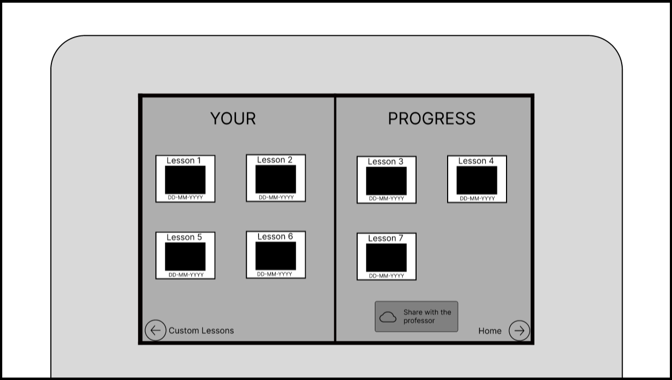

***Your Progress section:*** In this section you can see the list of lessons taken and for each of them there is the title, an image the date on which it was completed. In addition, there is also the button that allows the student to share their results with the professor.

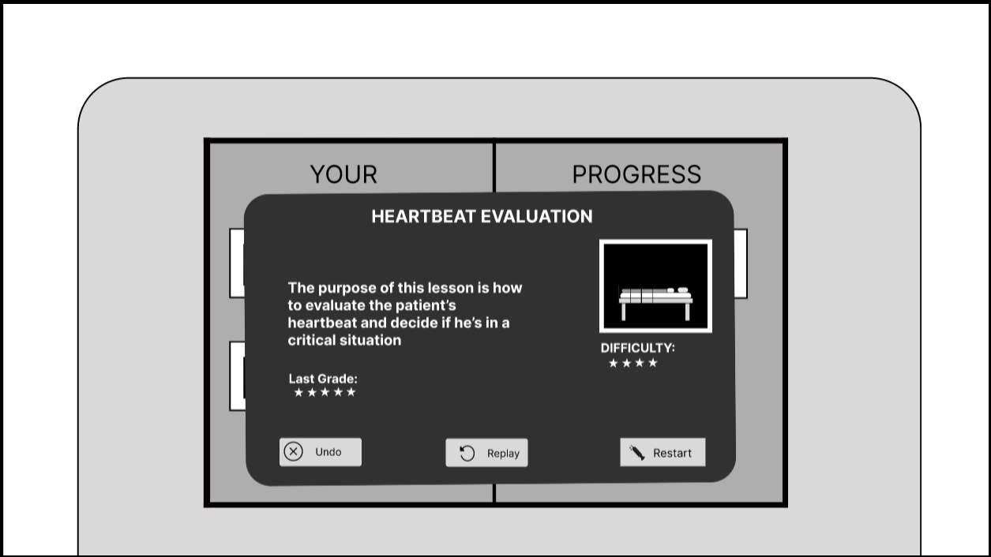

***Your Progress pop-up:*** For each lesson already carried out there is a pop-up that includes in addition to the title of the lesson, the description, the image and the level of difficulty, also the vote obtained, a button "replay", that allows you to review the lesson and a button "restart", which allows you to restart the lesson, losing however the assessment obtained.

## *Link to the interactive medium-fidelity prototype*

* ***Link To:*** [Figma Medium-Fidelity Prototype](https://www.figma.com/proto/JIg3ff0h3c2cFUUPsokQfh/Medical-Reality?node-id=40%3A11&scaling=contain&page-id=0%3A1&starting-point-node-id=40%3A11)

# ***HEURISTIC EVALUATION***

## *The heuristic evaluation received*

* ***Heuristic Evaluation description:***

We have received a very detailed heuristic evaluation, in which, on several things we agree, such as increasing the number of tips received by the application, so as to think more solid the complex task, but not on everything. In fact, we believe that some violations found have an excessive degree: we have in fact 20 violations with severity 3 or 4 in 34 found, which should indicate problems for which the application cannot work, when in fact, for some, it is not so. For example, in violation 4 is highlighted, with severity 4 the absence of a scroll bar, in case there were more lessons, when in fact we had inserted a few lessons as it was a prototype and in any case if a number of objects on a page, falls within the size of the element that contains it, the slider bar never appears. Moreover, several violations with severity 3 that go to criticize functions not present in our prototype, when the focus of the evaluation had to be directed towards the elements already present, such as the violation 10 and the 16.

* ***Link to:*** [Heuristic Evaluation online spreadsheet](https://docs.google.com/document/d/1qhnyPuogL4DbhGpxKSexwo5EOV4ihhpS2UgR2ghrdY0/edit)

## *Severity level 3 or 4 heuristic violations*

* ***H1:*** *Visibility of system status / Found by: E1*

***Where:*** *Teacher Lessons and Your Progress interfaces*

***What:*** *The complex task is not written correctly*

***Why:*** *There is no explicit way in which the user receives the feedback, which is what the task should do*

***Severity:*** *4*

* + We are partially in agreement: the complex task is written correctly and there is also the way the application provides feedback to the user, through the label "suggested" placed on certain lessons. However, we agree that the number of tips that the student receives must increase.
* ***H1****: Visibility of system status / Found by: E3*

***Where:*** *when ending a lesson*

***What:*** *there is no feedback at all when a lesson ends.*

***Why:*** *the user is not shown any feedback when the lesson ends, neither related to state or to their performance.*

***Severity:*** *4*

* + We agree: we add a page containing the feedback that the application is able to release to the user, when he finishes a lesson, thus also covering the previous violation.
* ***H4:*** *Consistency and standards / Found by: E2*

***Where:*** *Teacher lessons and Your progress pages*

***What:*** *The lessons pagination*

***Why:*** *If more than 8 lessons are present there is no way to scroll them*

***Severity:*** *4*

* + We are partially in agreement: the scroll bar was not present as the number of lessons falls within the prototype screen and even if a container is scrollable, when the number of elements does not exceed the size of the same, scrollable bar does not appear visually; so it is not our fault. In any case, as we had already intended to do, having more lessons to show we will use a scroll bar.
* ***H2:*** *Match between system and the real world - H5: Error prevention / Found by: E2 and E4*

***Where:*** *In page “Custom Lessons” of the menu*

***What:*** *The “START” button should be disabled or show errors when some options aren’t selected*

***Why:*** *The user shouldn’t be allowed to start a lesson unless every option is set*

***Severity****: 4*

* + We agree, but remove "Custom lessons" features from the prototype as it is auxiliary to the coverage of the selected tasks.
* ***H1:*** *Visibility of system status / Found by: E1 and E4*

***Where:*** *In the home page*

***What****: Absence of application title*

***Why:*** *The user should know they have accessed the application*

***Severity****: 3*

* + We agree: we add the title in the home page.
* ***H1:*** *Visibility of system status / Found by: E1 and E3*

***Where:*** *Teacher Lessons interface*

***What:*** *"Suggested" icon*

***Why:*** *There’s not much feedback about the suggestion of lessons: it is unclear when the lesson is suggested for the user (it is part of the complex task)*

***Severity****: 3*

* + We are partially in agreement: each suggested lesson is already marked with a special "suggested" label, but on the end of the lesson page, which returns the feedback to the user, we also reminded the user to follow the recommended lessons, so as to make it as clear as possible.
* ***H1:*** *Visibility of system status / Found by: E1*

***Where:*** *Your Progress interface*

***What:*** *An interface resuming the statistics about the user is missing*

***Why:*** *It is unclear in which way the lessons are suggested for the single user*

***Severity:*** *3*

* + We partially in agreement: the lessons are suggested to the user based on the evaluation obtained in the individual tasks performed in the various lessons, which are visible on the feedback page at the end of the lesson and at any time in the "your progress" section. The lessons are suggested to the user based on its shortcomings and he is reminded of this as explained in the response of the previous breach. While, an interface that summarizes all the user’s statistics will not be inserted because it is not strictly related to the coverage of our tasks (in fact, initially we had inserted a section "statistics", which the professor had indicated us to remove).
* ***H4:*** *Consistency and standard / Found by: E4*

***Where:*** *In the menu*

***What:*** *The star rating system is used to show both the difficulty of a lesson and the grade obtained by the user.*

***Why:*** *It’s unclear which metric the unlabeled 5-stars ratings in the pages are related to. If the user clicks on the lesson card to retrieve more information in page “Teacher Lessons”, a 5-star rating labeled as “difficulty” is shown. This is even more confusing, because it makes the user think that the rating in the card is about the same metric, while it is about the grade.*

***Severity:*** *3*

* + We agree: we have replaced the way in which assessments are represented, leaving only to the difficulty representation through stars, to make everything clearer.
* ***H4****: Consistency and standard / Found by: E2 and E4*

***Where:*** *In page “Custom Lessons” of the menu*

***What****: The fourth option is labeled as “Hospital Room” but in the selection pop-up its name is “intervention room” and “Hospital Room” is one of the possible selections*

***Why:*** *It is confusing to have different names for the same option. In addition, it looks like “Hospital Room” is the selected place even if it isn’t.*

***Severity:*** *3*

* + We agree, but remove "Custom lessons" features from the prototype as it is auxiliary to the coverage of the selected tasks.
* ***H4:*** *Consistency and standards / Found by: E4*

***Where:*** *In page “Custom Lessons” of the menu*

***What****: You cannot choose difficulty when creating a custom lesson*

***Why:*** *Since predefined lessons have an associated difficulty value, the user may expect the custom lessons to have several difficulties too. If difficulty is given by the combination of selected body type, type of intervention, criticality level and intervention room, the user must be notified nonetheless*

***Severity:*** *3*

* + we do not agree: the lessons difficulty of the professor is defined by him and not by the application and it is based on how difficult he considers the completion of the tasks he inserted within the lesson. The idea of "Custom lesson" instead was to allow the user to practice a single task, among all those inserted by the professor, also changing some parameter, but the difficulty level of the same can not be defined by the application. Anyway we remove "custom lessons" features from the prototype as it is auxiliary to the coverage of the selected tasks.
* ***H5:*** *Error prevention / Found by: E1 and E4*

***Where:*** *Pop-up in Custom Lessons interface*

***What:*** *"Confirm" button should not be clickable if the user did not make a choice*

***Why:*** *A default option is missing, so the user has to choose what to do; it is in contrast with this constraint. The user should be asked for confirmation about the options they set before starting a lesson to be sure that they entered the desired values*

***Severity:*** *3*

* + We agree, but remove "Custom lessons" features from the prototype as it is auxiliary to the coverage of the selected tasks.
* ***H6:*** *Recognition rather than recall / Found by: E4*

***Where:*** *In the “Lesson X” screen*

***What:*** *Missing information in the lesson*

***Why:*** *The user should be able to see the data about the lesson they are in. Difficulty, body type, type of intervention, criticality level and intervention room are missing.*

***Severity:*** *3*

* + we do not agree: each lesson before being started presents a description inserted by the professor in which it is specified what will be presented to the student within the lesson. Once the lesson starts, the user will have it in front of him, it is superfluous to tell him what he has in front of him, what he must do he has already indicated by the tasks.
* ***H6****: Recognition rather than recall / Found by: E4*

***Where:*** *In page “Teacher Lessons” of the menu*

***What:*** *Missing information in the lesson preview*

***Why:*** *The user should be able to see the data about the lesson they are going to start. Only difficulty and a brief description are shown, while body type, type of intervention, criticality level and intervention room are missing.*

***Severity:*** *3*

* + we agree: in addition to the description and the level of difficulty already present, we add the parameters required for greater clarity for the user.
* ***H6:*** *Recognition rather than recall / Found by: E2, E3 and E4*

***Where:*** *In page “Custom Lessons” of the menu*

***What****: The function of the “Replay” isn’t clear*

***Why:*** *The name given to the option is too general and unrelated with its actual function, the only way to really know what the button does is to have selected it before and remembering what it does.*

***Severity:*** *3*

* + we agree: the correct name of the option is "ability to rewind during the lesson" and should be present within the lesson itself a button to enable it. Our idea was that once pressed it would bring you back to the previous state (e.g., to the previous task), but in any case we remove "Custom lessons" features from the prototype as it is auxiliary to the coverage of the selected tasks.
* ***H7:*** *Flexibility and efficiency of use / Found by: E2*

***Where:*** *Lesson from Teacher Lessons or Your Progress interfaces*

***What:*** *Pause and Play button are always present*

***Why:*** *Only one of them is pushable, it’s useless to have two buttons*

***Severity:*** *3*

* + we agree: one button must replace the other in the same position
* ***H1:*** *Visibility of system status - H4: Consistency and standards / Found by: E1*

***Where:*** *Your Progress and Teacher Lessons interfaces*

***What:*** *Updating on lesson evaluation/difficulty*

***Why:*** *The user is not notified when a lesson he has done is updated with the new status, which is available when the user shares the results to the teacher*

***Severity:*** *3*

* + we do not agree: the professor cannot change the lesson difficulty already loaded. This is not part of our task and in any case he could at most fix some possible bug present, but this would not affect the mark already obtained by the student.
* ***H1****: Visibility of system status - H8: Aesthetic and minimalist design / Found by: E1, E3 and E4*

***Where:*** *In the home page*

***What:*** *Too many unusable items, hard to understand what you can do*

***Why:*** *The home page is filled with useless items which make the screen messy and create confusion about the actually usable one (the menu book), which is shown in a small portion of the screen.*

***Severity:*** *3*

* + we disagree: our prototype is designed for use in virtual reality, so the surrounding environment was created to simulate reality, but this does not imply that each element is clickable. Our idea is that the student is at the desk and without the ability to move uses the book in front of him to "study".
* ***H1:*** *Visibility of system status - H5: Error prevention - H6: Recognition rather than recall / Found by: E1 and E2*

***Where:*** *Custom Lessons interface*

***What:*** *A pop-up window of confirmation of the options inserted by the user is missing*

***Why:*** *The user should not be forced to memorize the options that they have inserted. The user can accidentally start a lesson with wrong parameters*

***Severity:*** *3*

* + we do not agree: is already present in the medium-fidelity prototype a field that specifies to the user which element has selected for each parameter (each of them fixed to "undefined" as a prototype), but in any case we remove "Custom lessons" features from the prototype as it is auxiliary to the coverage of the selected tasks.
* ***H3:*** *User control and freedom - H7: Flexibility and efficiency of use / Found by: E3*

***Where:*** *menu*

***What****: there's no way to reach different options if not by scrolling through the pages of the menu.*

***Why:*** *the user has no flexibility to skip parts of the menu if they know what they are trying to reach, having to skip through all the pages to reach the last one; an index could be a good addition.*

***Severity:*** *3.*

* + we partially agree: the index to speed up the scrolling of the book is a great idea, except for the fact that our book was only three pages, so the maximum number of pages to scroll was two. We would have added an index anyway, but eliminating the "Custom Lessons" section, the pages become two and the use of an index that appears when you open the first page becomes completely useless.
* ***H4:*** *Consistency and standards - H6: Recognition rather than recall / Found by: E1 and E4*

***Where:*** *Teacher Lessons and Your Progress interfaces*

***What:*** *The meaning behind the empty stars icons is unclear*

***Why:*** *It could mean that the lesson is not done or that the evaluation/difficulty equals to zero. Is it even possible to grade a lesson with zero stars?*

***Severity:*** *3*

* + we partially agree: this violation is a repetition of violation number 8. As already mentioned, we have changed the way of representation of the student’s assessment and the stars remained are to represent the difficulty of the lesson, defined by the professor.

## *Plan to solve the identified violations*

* ***H1:*** *Visibility of system status / Found by: E1*

***Where:*** *Teacher Lessons and Your Progress interfaces*

***What:*** *The complex task is not written correctly*

***Why:*** *There is no explicit way in which the user receives the feedback, which is what the task should do*

***Severity:*** *4*

* + Fix: we added a page at the end of the lesson where the student is specified the results obtained by themselves, with a vote for each task, plus a final evaluation derived from the previous ones.
* ***H1****: Visibility of system status / Found by: E3*

***Where:*** *when ending a lesson*

***What:*** *there is no feedback at all when a lesson ends.*

***Why:*** *the user is not shown any feedback when the lesson ends, neither related to state or to their performance.*

***Severity:*** *4*

* + Fix: we added a page at the end of the lesson where the student is specified the results obtained by themselves, with a vote for each task, plus a final evaluation derived from the previous ones.
* ***H4:*** *Consistency and standards / Found by: E2*

***Where:*** *Teacher lessons and Your progress pages*

***What:*** *The lessons pagination*

***Why:*** *If more than 8 lessons are present there is no way to scroll them*

***Severity:*** *4*

* + Fix: We added a scroll bar always visible to scroll through the list of lessons present.
* ***H2:*** *Match between system and the real world - H5: Error prevention / Found by: E2 and E4*

***Where:*** *In page “Custom Lessons” of the menu*

***What:*** *The “START” button should be disabled or show errors when some options aren’t selected*

***Why:*** *The user shouldn’t be allowed to start a lesson unless every option is set*

***Severity****: 4*

* + Fix: we removed the "Custom lessons" section.
* ***H1:*** *Visibility of system status / Found by: E1 and E4*

***Where:*** *In the home page*

***What****: Absence of application title*

***Why:*** *The user should know they have accessed the application*

***Severity****: 3*

* + Fix: we have added the application name inside the home.
* ***H1:*** *Visibility of system status / Found by: E1 and E3*

***Where:*** *Teacher Lessons interface*

***What:*** *"Suggested" icon*

***Why:*** *There’s not much feedback about the suggestion of lessons: it is unclear when the lesson is suggested for the user (it is part of the complex task)*

***Severity****: 3*

* + Fix: in the feedback page at the end of the lesson, we added a reminder for the student to follow the lessons marked with the appropriate label "suggested".
* ***H1:*** *Visibility of system status / Found by: E1*

***Where:*** *Your Progress interface*

***What:*** *An interface resuming the statistics about the user is missing*

***Why:*** *It is unclear in which way the lessons are suggested for the single user*

***Severity:*** *3*

* + Partially fix: we have added an end of lesson page that contains feedback for the student related to that specific lesson, but we have not added a page that summarizes all the general static of the student because it does not fit into our tasks.
* ***H4:*** *Consistency and standard / Found by: E4*

***Where:*** *In the menu*

***What:*** *The star rating system is used to show both the difficulty of a lesson and the grade obtained by the user.*

***Why:*** *It’s unclear which metric the unlabeled 5-stars ratings in the pages are related to. If the user clicks on the lesson card to retrieve more information in page “Teacher Lessons”, a 5-star rating labeled as “difficulty” is shown. This is even more confusing, because it makes the user think that the rating in the card is about the same metric, while it is about the grade.*

***Severity:*** *3*

* + Fix: we used the stars to represent the difficulty level of the lessons, defined by the professor, while for the evaluation of the student we used the structure of American grades, namely: A, B, C, D and F.
* ***H4****: Consistency and standard / Found by: E2 and E4*

***Where:*** *In page “Custom Lessons” of the menu*

***What****: The fourth option is labeled as “Hospital Room” but in the selection pop-up its name is “intervention room” and “Hospital Room” is one of the possible selections*

***Why:*** *It is confusing to have different names for the same option. In addition, it looks like “Hospital Room” is the selected place even if it isn’t.*

***Severity:*** *3*

* + Fix: we removed the "Custom lessons" section.
* ***H4:*** *Consistency and standards / Found by: E4*

***Where:*** *In page “Custom Lessons” of the menu*

***What****: You cannot choose difficulty when creating a custom lesson*

***Why:*** *Since predefined lessons have an associated difficulty value, the user may expect the custom lessons to have several difficulties too. If difficulty is given by the combination of selected body type, type of intervention, criticality level and intervention room, the user must be notified nonetheless*

***Severity:*** *3*

* + Fix: we removed the "Custom lessons" section.
* ***H5:*** *Error prevention / Found by: E1 and E4*

***Where:*** *Pop-up in Custom Lessons interface*

***What:*** *"Confirm" button should not be clickable if the user did not make a choice*

***Why:*** *A default option is missing, so the user has to choose what to do; it is in contrast with this constraint. The user should be asked for confirmation about the options they set before starting a lesson to be sure that they entered the desired values*

***Severity:*** *3*

* + Fix: we removed the "Custom lessons" section.
* ***H6:*** *Recognition rather than recall / Found by: E4*

***Where:*** *In the “Lesson X” screen*

***What:*** *Missing information in the lesson*

***Why:*** *The user should be able to see the data about the lesson they are in. Difficulty, body type, type of intervention, criticality level and intervention room are missing.*

***Severity:*** *3*

* + Unfixable: the student has already read the parameters of the lesson and started it, has the lesson in front and there is no need to remind him what he is watching. What he must do is already specified by the tasks that are indicated to him during the lesson.
* ***H6****: Recognition rather than recall / Found by: E4*

***Where:*** *In page “Teacher Lessons” of the menu*

***What:*** *Missing information in the lesson preview*

***Why:*** *The user should be able to see the data about the lesson they are going to start. Only difficulty and a brief description are shown, while body type, type of intervention, criticality level and intervention room are missing.*

***Severity:*** *3*

* + Unfixable: We have not specified these parameters for each lesson, as we have removed the "Custom lessons" section, so there is no longer a mismatch with it. Each lesson is represented by a title and a short description, sufficient for these small lessons; our idea is to provide “lessons in pills”.
* ***H6:*** *Recognition rather than recall / Found by: E2, E3 and E4*

***Where:*** *In page “Custom Lessons” of the menu*

***What****: The function of the “Replay” isn’t clear*

***Why:*** *The name given to the option is too general and unrelated with its actual function, the only way to really know what the button does is to have selected it before and remembering what it does.*

***Severity:*** *3*

* + Fix: we removed the "Custom lessons" section.
* ***H7:*** *Flexibility and efficiency of use / Found by: E2*

***Where:*** *Lesson from Teacher Lessons or Your Progress interfaces*

***What:*** *Pause and Play button are always present*

***Why:*** *Only one of them is pushable, it’s useless to have two buttons*

***Severity:*** *3*

* + Fix: we replaced one button with the other every time one of the two is clicked
* ***H1:*** *Visibility of system status - H4: Consistency and standards / Found by: E1*

***Where:*** *Your Progress and Teacher Lessons interfaces*

***What:*** *Updating on lesson evaluation/difficulty*

***Why:*** *The user is not notified when a lesson he has done is updated with the new status, which is available when the user shares the results to the teacher*

***Severity:*** *3*

* + Unfixable: the professor cannot change the lesson difficulty already loaded; this is not part of our task.
* ***H1****: Visibility of system status - H8: Aesthetic and minimalist design / Found by: E1, E3 and E4*

***Where:*** *In the home page*

***What:*** *Too many unusable items, hard to understand what you can do*

***Why:*** *The home page is filled with useless items which make the screen messy and create confusion about the actually usable one (the menu book), which is shown in a small portion of the screen.*

***Severity:*** *3*

* + Unfixable: the home represents a virtual room, not all the elements must be clickable. We added an arrow indicating the book (menu) to indicate more clearly to the user what to click.
* ***H1:*** *Visibility of system status - H5: Error prevention - H6: Recognition rather than recall / Found by: E1 and E2*

***Where:*** *Custom Lessons interface*

***What:*** *A pop-up window of confirmation of the options inserted by the user is missing*

***Why:*** *The user should not be forced to memorize the options that they have inserted. The user can accidentally start a lesson with wrong parameters*

***Severity:*** *3*

* + Fix: we removed the "Custom lessons" section.
* ***H3:*** *User control and freedom - H7: Flexibility and efficiency of use / Found by: E3*

***Where:*** *menu*

***What****: there's no way to reach different options if not by scrolling through the pages of the menu.*

***Why:*** *the user has no flexibility to skip parts of the menu if they know what they are trying to reach, having to skip through all the pages to reach the last one; an index could be a good addition.*

***Severity:*** *3.*

* + Unfixable: the book (menu) has only two pages, an index is not necessary.
* ***H4:*** *Consistency and standards - H6: Recognition rather than recall / Found by: E1 and E4*

***Where:*** *Teacher Lessons and Your Progress interfaces*

***What:*** *The meaning behind the empty stars icons is unclear*

***Why:*** *It could mean that the lesson is not done or that the evaluation/difficulty equals to zero. Is it even possible to grade a lesson with zero stars?*

***Severity:*** *3*

* + Fix: we used the stars to represent the difficulty level of the lessons, defined by the professor, while for the evaluation of the student we used the structure of American grades, namely: A, B, C, D and F.
* ***H1:*** *Visibility of system status / Found by: E1*

***Where:*** *Teacher Lessons and Your Progress interfaces*

***What:*** *Lessons evaluation/difficulty*

***Why****: It is unclear how the evaluation is done*

***Severity:*** *2*

* + Fix: we have put in the page before the start of the lesson a note that reminds the user that the more mistakes he makes during the course of the lesson and the longer it takes to do it the less his evaluation will be.
* ***H3:*** *User control and freedom / Found by: E1*

***Where:*** *Lesson X interface*

***What:*** *Save progress in the middle of the lesson*

***Why:*** *The user is forced to complete the lesson to save their progresses*

***Severity:*** *2*

* + Unfixable: the ability to keep track of lessons already started, maintaining a rescue of the same, does not fall within our tasks.
* ***H3****: User control and freedom / Found by: E2*

***Where****: Lesson X interface*

***What****: You can’t push the symbol at the center of the screen to continue the lesson*

***Why****: The pause symbol seems to be clickable*

***Severity****: 2*

* + Fix: our idea was that it was not a pulsed, but only an image that stood in front of the screen to indicate that the lesson was blocked, but to avoid ambiguity we removed it
* ***H4****: Consistency and standards / Found by: E1 and E2*

***Where****: Teacher Lessons and Your Progress interfaces*

***What****: The meaning behind the stars under the lessons is unclear*

***Why****: It could mean many different things, such as difficulty or evaluation*

***Severity****: 2*

* + Fix: this is the third time the same violation is repeated, anyway we used the stars to represent the difficulty level of the lessons, defined by the professor, while for the evaluation of the student we used the structure of American grades, namely: A, B, C, D and F.
* ***H4****: Consistency and standards / Found by: E1, E2 and E3*

***Where****: In every window with a "go back" action*

***What****: The option to go back is "Undo" rather than "Back"*

***Why****: It can be slightly misleading, since the “Undo” button usually has a different purpose*

***Severity****: 2*

* + Fix: the term "undo" is also correct to indicate "something you don’t want to do anymore", for example when the choice is between "start" and "undo", but we replaced all the "undo" with the term "back" to avoid ambiguity.
* ***H4****: Consistency and standard / Found by: E4*

***Where****: In the menu*

***What:*** *Inconsistency on grade/date position between pages*

***Why****: In the page “Teacher Lessons”, the grade is expressed through five stars on the lesson card. In the “YOUR PROGRESS” page, that position is used to show the data, while the rating is moved inside the information pop-up.*

***Severity:*** *2*

* + Fix: we removed both so as to simplify and align the cards that represent the lessons in both sections.
* ***H4****: Consistency and standards / Found by: E4*

***Where****: In page “Your Progress” of the menu (after clicking on the “Share with the professor” button) and during the lecture (after clicking on the stop button)*

***What:*** *Position of confirmation/rejection buttons are inverted in relation to the other dialogs in the application*

***Why****: In every dialog of the application, the confirmation button (OK/yes/start/restart) is on the right and the reject button (no/undo) is on the left except for these ones*

***Severity****: 2*

* + Fix: we have placed all buttons forward and continuation on the right and all buttons cancellation and for backward to the left.
* ***H8****: Aesthetic and minimalistic design / Found by: E2, E3 and E4*

***Where****: In the menu.*

***What****: The title is split between the two “book pages” of the menu.*

***Why****: It’s unclear whether the two pages belong to the same voice of the menu or not. For example, it is not clear whether the first two pages are two voices called “Teacher” and “Lessons” or a single voice called “Teacher Lessons”*

***Severity:*** *2*

* + Fix: we disagree, actually it was totally clear that the title referred to both pages for various reasons: the pages could not be viewed individually, but only together, since they represent an open book, the elements contained in the iteration of the two pages are the same and the navigation elements to the other pages are shared by the two pages in question, just to indicate that they make up a single entity. In any case, we replaced the menu represented by a book to one represented by a medical record, consisting of a single page, so the problem does not arise.
* ***H1****: Visibility of system status - H6: Recognition rather than recall / Found by: E1 and E4*

***Where****: Lesson X interface*

***What****: There should be a label telling the user the type of time of the lesson (such as "time left" or "maximum reachable time")*

***Why****: It is not clear whether the time that is passing is a countdown to zero or just a counting to a maximum time*

***Severity****: 2*

* + Unfixable: the indicated time flows forward, no need to specify it to the user, while he has in front of the lesson with the time that is flowing forward, he sees it. It might not be totally clear in the medium-fidelity prototype, as it is composed of static screens, but there will be no chance of getting confused in the high-level prototype. The time is held, without a maximum limit, to be able to give an assessment to the student: the more time it takes, the lower the evaluation will be and this is explained in the feedback page at the end of class.
* ***H3****: User control and freedom - H7: Flexibility and efficiency of use / Found by: E3*

***Where****: Teacher lessons and Your progress pages*

***What****: lack of filtering/search bar*

***Why****: if the user knows what lesson they want exactly, there’s no way of getting to it besides scrolling through all the existing lessons, which seems inefficient.*

***Severity****: 2*

* + Fix: it is a good idea to have a filter system or a search bar when you are in the presence of a long list, but our list is not long (10 items) and this is not part of our tasks. In any case we have added a filter that shows only the suggested lessons, to better support our task, and indicate to the user in an even clearer way what should give priority.
* ***H1****: Visibility of system status / Found by: E1*

***Where****: Teacher Lessons interface*

***What****: The tick mark in a completed lesson is in a confusing position*

***Why****: It could be confused as an arrow of a drop-down menu (that, for example, explains the topic of the lesson); it would be better to put a "done" icon instead*

***Severity****: 1*

* + Fix: we replaced the tick mark with a special label "done" to indicate a lesson already done.
* ***H4****: Consistency and standards / Found by: E1 and E4*

***Where****: Teacher Lessons and Your Progress interfaces*

***What****: The titles are written in different ways: one is all with uppercase letters, while the other is written with both upper and lowercase letters*

***Why****: There should not be inconsistency in the way they are written, since both of them are titles and have the same relevance*

***Severity****: 1*

* + Fix: we wrote all the titles in uppercase, so as to align them.
* ***H2****: Match between system and the real world - H8: Aesthetic and minimalist design / Found by: E2*

***Where****: The whole application*

***What:*** *The menu style*

***Why****: That style recall a restaurant format, not a medical environment*

***Severity****: 1*

* + Fix: we disagree, actually the menu represented a schoolbook, with the titles at the top and images, text and elements in the body of the book. In any case we replaced it with a clinic report, so as to give even more sense of hospital situation.

# ***HIGH-FIDELITY PROTOTYPE***

## *How the high-fidelity prototype was created*

* ***Tools, framework and libraries used:*** 
  + For the fronted part, we used: React, React-Bootstrap, React-Router-Dom, React-Three, Days and Sketchfab (website from which we took the graphic models to be included in the prototype)
  + For the backend part, we used: Nestjs, TypeOr and PostgreSql
* ***Why:*** we used the React and Dayjs libraries to implement the frontend of the high-level prototype, as we had already used them during the course “Web Application 1” and we all already had enough knowledge of them; while we used React-Three to implement the 3D part of the prototype, which we were advised by the professor. Finally, for the backend we took advantage of the libraries that some of us had already used for the course "Software Engineering 2", therefore already having some notions about them.

## *Link to the high-fidelity prototype GitHub repository*

* ***Link to:*** [High-Level Prototype GitHub repository](https://github.com/polito-hci-2022/Medical-Reality)

## *Overall architecture of the application*

* ***Overall architecture of the application:***

The application, designed for use through a headset, and exemplified in the high-level prototype using the browser on the PC, simulates a student inside a hospital room sitting at a desk, who through a medical record can select and perform a lesson related to his learning as preparation for the internship for the medical university. Once the lesson starts, he will be in front of a cot with a dummy on which to perform medical processes, a bench with the tools he will use and a blackboard that tells him what to do. Once the lesson is over, he will receive feedback about it, which will be visible at any time, along with the assessments obtained in the other lessons, through the same medical record used previously, which represents the application menu.

* ***The most significant screen:***

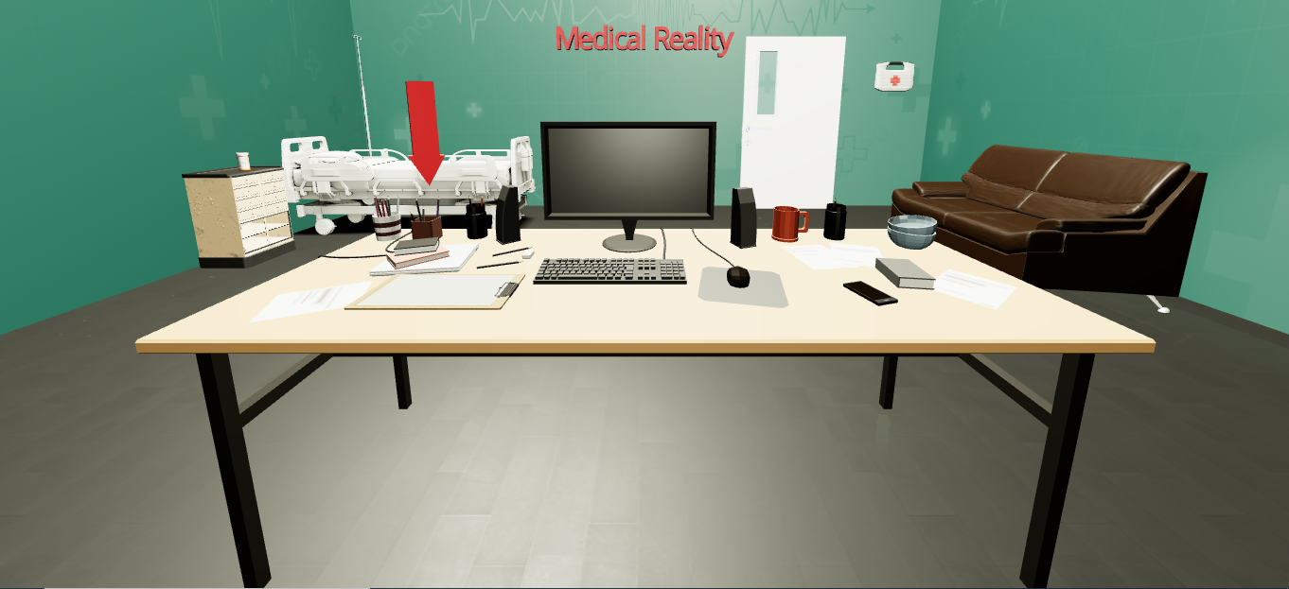

***Home Page:*** The home simulates a student at his desk in a hospital room; from here he has the ability to open the menu and navigate the application.

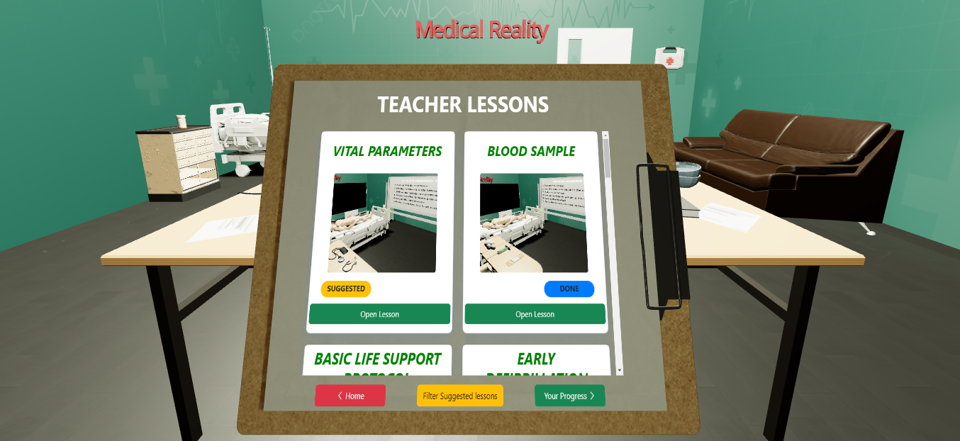

***Teacher Lessons:*** In this section the student can see all the lessons provided by the professor; each of them is highlighted by a title an image and possibly a "suggested" and/or "done" label. In addition, he has the ability to filter the suggested lessons.

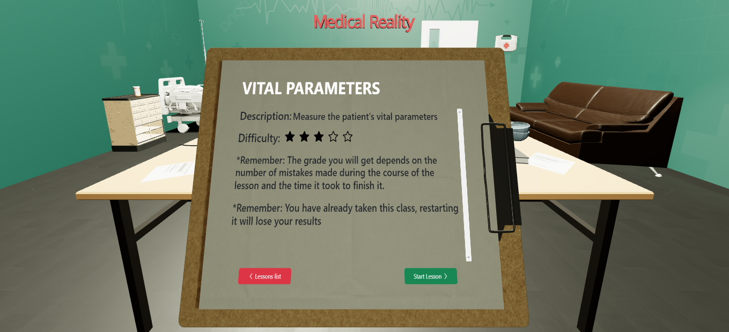

***Teacher Lesson Pop-Up:*** Clicked "open lesson" the user can see the description of the lesson and the level of difficulty, before starting it. In addition, there are notes about how the assessment is done.

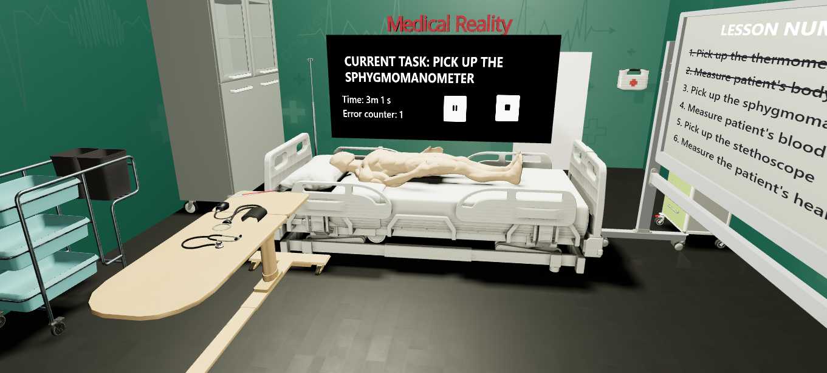

***Lesson X screen:*** During the lesson, the student is provided with a set of tools, located on a bench to the left, that he or she can use on the dummy in order to perform the tasks that are given to him to complete the lesson. The complete list of tasks is shown on the white board to the right, while the current task, along with the elapsed time, number of errors, and multimedia buttons, are on the central black board.

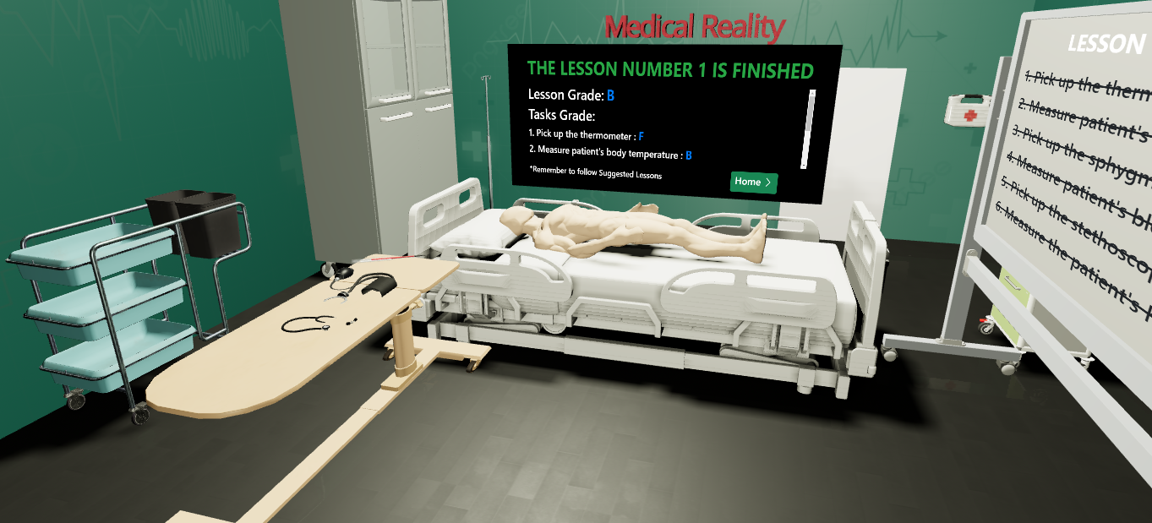

***Lesson X screen:*** Once the lesson is finished, the feedback page appears on the central black board, containing the overall rating, individual task ratings, and a note reminding the user to follow the suggested lessons.

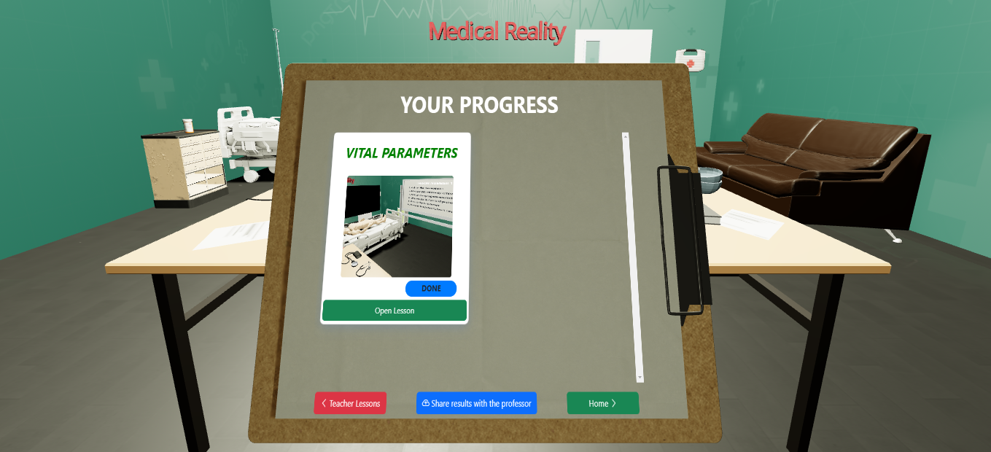

***Your Progress:*** In this section the student can see all the lessons he or she has taught and has the opportunity to share his or her achievements with the professor, via an external channel.

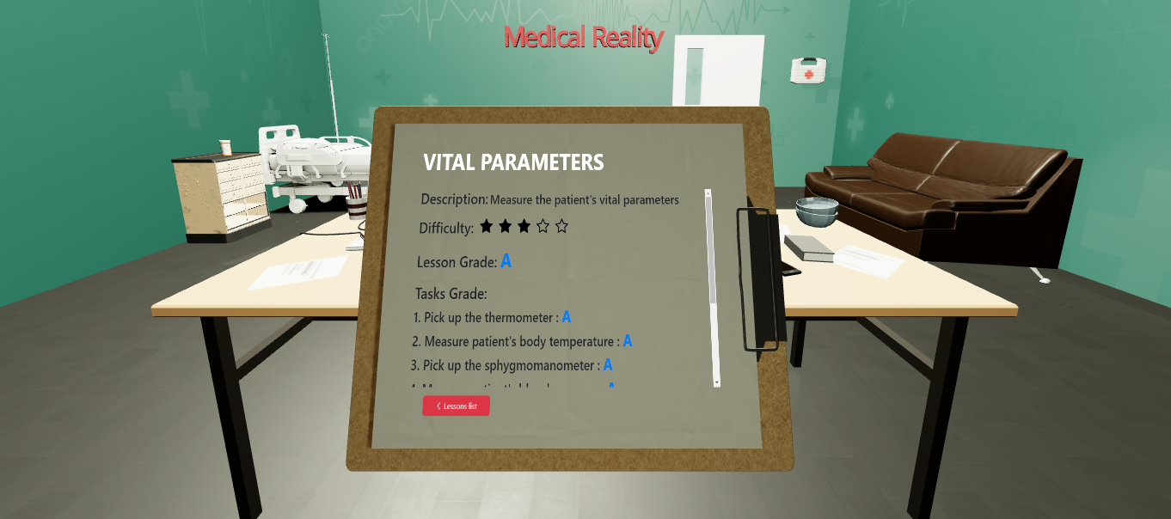

***Your Progress Pop-Up:*** By clicking on "open lesson," the user can see not only the name, description and difficulty level of the lesson, but also the overall grade obtained and the ratings of each individual task.

## *Hard-coded part, pre-stored data, and limitations*

* ***Hard-coded part:***

The hard-coded part, in the sense of something that you cannot change, of the high-level prototype are mainly three:

* + All the models used, which were downloaded from the website "Sketchfab" and inserted into the prototype via the hook "useLoader" of the library "React-three" and used the format "GLTFLoader" of the library “Three". They are contained in the path "/Medical-Reality/frontend/src/components"
  + The prototype simulates that the login has already happened, so you can use it through a single user profile
* ***Pre-stored data:***

Our pre-stored data is contained within a database created via PostgreSql. It consists of three main tables and two that contain the joins of the previous tables to speed up the recovery of data in frontend. The three main tables are:

* + "Lessons", containing the 10 lesions present in the prototype, not all executable
  + "Tasks", containing 15 tasks, some present in executable lessons, others related to other lessons, which however have not been implemented in frontend
  + "Tools", contains the 6 tools that can be used in the executable lessons
* ***Limitations:***

The limits of the high-level prototype, compared to the functionality that should have the application once last are mainly three:

* + Based on the file that we shared the coordinator of the medical pre-trainings at the "SimTo", simulation center at the Molinette Hospital in Turin, the lessons, which she recorded and then shared with medical students for their preparation for the pre-trainings, it was 10. We have them all in our prototype, but as such, we have developed the execution of only two lessons.
  + The execution of the lessons we have developed is not completed. The general structure of the execution, that is the composition in task is complete, but the number of them to complete is limited.
  + To maximize immersivity and realism, thus allowing the student to approach in the most appropriate way possible to trainings, our application is designed to be used through a Visor, so that the user can operate using the hands, simulating the real world to the fullest. But having developed a prototype and not having any kind of skills, neither in 3D programming, nor in programming for devices like Visor, we have developed the high-level prototype in the safest way, so it runs on PC via browser.

# ***USABILITY TESTING***

## *Preparation and run*

### *Evaluation conducted*

* ***Participants:***
  + [Alessio Camisassa, second-year medical student, UniTO](https://github.com/polito-hci-2022/Front-end-Avengers/tree/main/A6/UsabilityTest_Documents/usabilityTest_AlessioCamisassa)
  + [Eleonora Cutrino, third-year medical student, UniTO](https://github.com/polito-hci-2022/Front-end-Avengers/tree/main/A6/UsabilityTest_Documents/usabilityTest_EleonoraCutrino)
  + [Lucrezia Carbone, second-year medical student, UniTO](https://github.com/polito-hci-2022/Front-end-Avengers/tree/main/A6/UsabilityTest_Documents/usabilityTest_LucreziaCarbone)
  + [Giorgia Bordin, third-year medical student, UniTO](https://github.com/polito-hci-2022/Front-end-Avengers/tree/main/A6/UsabilityTest_Documents/usabilityTest_GiorgiaBordin)
  + [Delia Bellino, fourth-year medical student, UniTO](https://github.com/polito-hci-2022/Front-end-Avengers/tree/main/A6/UsabilityTest_Documents/usabilityTest_DeliaBellino)
* ***Team members role:***
  + Lorenzo Sciara will be the facilitator
  + Benito Marra, Francesco Grande and Luca Rota will be the observers
* ***Where evaluation was conducted:***

All evaluations were conducted at the University of Medicine in Turin.

* ***How evaluation was conducted:***

The evaluations were carried out following the methodologies and exploiting the artifacts specified in the report dedicated to Usability Testing.

* ***Refined set of tasks:***

After asking for a first initial impression on our prototype, we asked participants to run the 3 main tasks we defined: simple task, moderate task and complex task.

### *Link to the usability testing protocol PDF*

* ***Link to:*** [Usability Testing Report and forms](https://github.com/polito-hci-2022/Front-end-Avengers/tree/main/A6)

## *Results*

### *The results and findings summary*

* ***SUS Results:*** 76 (average)
  + Alessio Camisassa: 95
  + Eleonora Cutrino: 50
  + Lucrezia Carbone: 95
  + Giorgia Bordin: 67
  + Delia Bellino: 73
* ***Measuring Success Task1:*** 
  + Difficulty average, scale from 1 (very difficult) to 7 (very easy): 5,2.

|  |  |  |
| --- | --- | --- |
| Level of Success | Number of users | How you report it |
| Complete Success | 1 | Task completed without errors and in a time commensurate with its difficulty. |
| Success with a minor issue | 3 | Task completed with few errors and/or with slightly more time than expected. |
| Success with a major issue | 1 | Task completed with many errors and/or with much more time than expected. |
| Failure | 0 | Task not completed. |

* ***Measuring Success Task2:*** 
  + Difficulty average, scale from 1 (very difficult) to 7 (very easy): 5,6.

|  |  |  |
| --- | --- | --- |
| Level of Success | Number of users | How you report it |
| Complete Success | 2 | Task completed without errors and in a time commensurate with its difficulty. |
| Success with a minor issue | 3 | Task completed with few errors and/or with slightly more time than expected. |
| Success with a major issue | 0 | Task completed with many errors and/or with much more time than expected. |
| Failure | 0 | Task not completed. |

* ***Measuring Success Task3:*** 
  + Difficulty average, scale from 1 (very difficult) to 7 (very easy): 6,4.

|  |  |  |
| --- | --- | --- |
| Level of Success | Number of users | How you report it |
| Complete Success | 4 | Task completed without errors and in a time commensurate with its difficulty. |
| Success with a minor issue | 1 | Task completed with few errors and/or with slightly more time than expected. |
| Success with a major issue | 0 | Task completed with many errors and/or with much more time than expected. |
| Failure | 0 | Task not completed. |

### *Information learned about the prototype*

Through these usability tests, we realized that most people would be interested in reusing our application or otherwise being able to have a similar application that would allow them to practice, albeit virtually, in a direct way, before starting their medical internships and pre-internships.

People interviewed generally did not find consistency problems within the prototype, but on the contrary pointed to a well-integrated system. Also removed small initial problems, then people became familiar with the application, declaring it fairly simple.

There is also to be said that in some cases the interviewees were not too bright: for example, some had difficulty finding the initial menu, despite the fact that it is indicated by an overly large red arrow, which clashes with the rest of the environment and indicates precisely where one should click to open the menu; but that is what a software engineer should expect.

### *Potential changes to fix the main issues emerged*

* ***Potential changes about Task1:***
  + Improve the way one moves within the virtual environment
    - From some usability tests it was found that the use of a laptop mouse is not accurate enough to navigate in the virtual environment, this is actually not a problem, as the prototype we presented was developed to be used via PC, but the idea of our application is that it should be developed for use via visors, this would allow to move the view through the use of the head, thus being able to better choose where to direct one's focus.
  + Change the way the menu is represented
    - Although our menu is represented by a medical record, so as to make it friendly for medical students and is indicated by a large red arrow, we have highlighted how now the students to study place their total attention to electronic devices, such as the computer inside our home page, so it would be better to use it directly to access the menu.
* ***Potential changes about Task2:***
  + Improve the visibility of the share button
    - In some cases, there has been reported the poor visibility of the button that allows us to share the results obtained with the professor through an external channel; following the suggestions taken, we could create a new more specific section, in which there is only this button, plus maybe the list of lessons already shared with the professor and which not, information already present server side, but never shared with the student.
* ***Potential changes about Task3:***
  + Improve the visibility of the filter button for the suggested lessons
    - This task falls into the complex category as it provides intelligence within the application, which based on the errors and the time committed by users in performing the lessons, returns feedback, such as grades at the end of lessons and on the basis of them, taking into account also the correlations of the lessons, suggests the student which to follow. Getting all this information, however, for the user is very simple, so we have detected almost no problem, because the suggested lessons will be specially marked with a special label "Suggested" and we have also introduced a filter, that by pressing a button allows you to filter from the complete list of lessons, only those suggested, in order to facilitate the search. Only in one case we have been shown in problem that that button is not sufficiently clear, so wanting to solve anyway this problem, the solution would be, as in the previous case, create a section within the menu completely dedicated to the lessons suggested by the application.

# ***CONCLUSIONS***

## *Main learnings in the course*

First, our team was formed by a group of friends, whom we met while attending the master’s course at the Polytechnic of Turin.  
Thanks to this course we were able to work together for the first time and improve our synergy. In addition to the improvement related to teamwork, division and work organization, in this semester we learned several notions related to software development.   
Already in other courses we had studied techniques related to this development, but on this occasion, we could start from the origin of the process, actively taking part in preliminary situations that are not encountered in other types of courses. For example, none of us had ever done interviews or related with third parties and then developed a project following their real, real needs.   
In addition to this more human component, the different phases of the course allowed us to learn the basic knowledge of different tools useful for the realization of the prototypes we made, with whom none of us had ever had at what stage and for whom therefore we had no kind of practical skills. For example, we learned the basics of Figma for the realization of the medium-level prototype and React-Three, useful library for 3D design, viewable through Browser, for the development of our high-level prototype.

As for the theme of the project, it was not immediately seen, as it did not refer to our first choice made at the beginning of the course, but during the semester we were able to appreciate our choice, because it allowed us to learn new notions about virtual reality, which none of us had ever had to deal with in university, requiring us yes, to put ourselves in play and to effect greater effort in the field of programming and modeling of the prototypes, but giving them in the end greater satisfactions.

Finally, our project in particular, has allowed us to discover some information related to the medical field, such as the operation of internships related to the degree course in medicine and pre-internships, which in some universities we have learned that are carried out in a practical way and in others only in a theoretical way. For example, thanks to the interview we made to the general coordinator of the "SimTo", simulation center at the Molinette Hospital in Turin, allowed us to see closely how the students perform their pre-internships, so that we can better identify with the medical students and be able to better understand their needs.

## *Group feedback*

Having already a relationship outside the group formed for this course, we were able to organize ourselves as optimally as possible and stay in touch. according to the design phase of our prototype, from the first part of the interviews to the definition of the interviewees' needs, to the definition of the tasks and the realization of the various prototypes, each member of the group took an active part in the realization of the project.

For example, during the interview phase, each time a different person asked questions, while someone else took notes, while others were not present. or during the realization of low-level prototypes some have taken care of the part related to a device, while others to the other device.

Regarding the positive aspects of this group work there were several, mainly related to our human relationship as fellow students and friends, as mentioned before in fact we were able to know each other better during the course of the semester, always staying in touch and thus increasing our synergy.

While as for the negative aspects, of course there were, working in a group cannot always be perfect, often we had conflicting decisions with each other, but in the end we were able to solve, voting by majority, not simple being the group formed by four people, or in other ways.